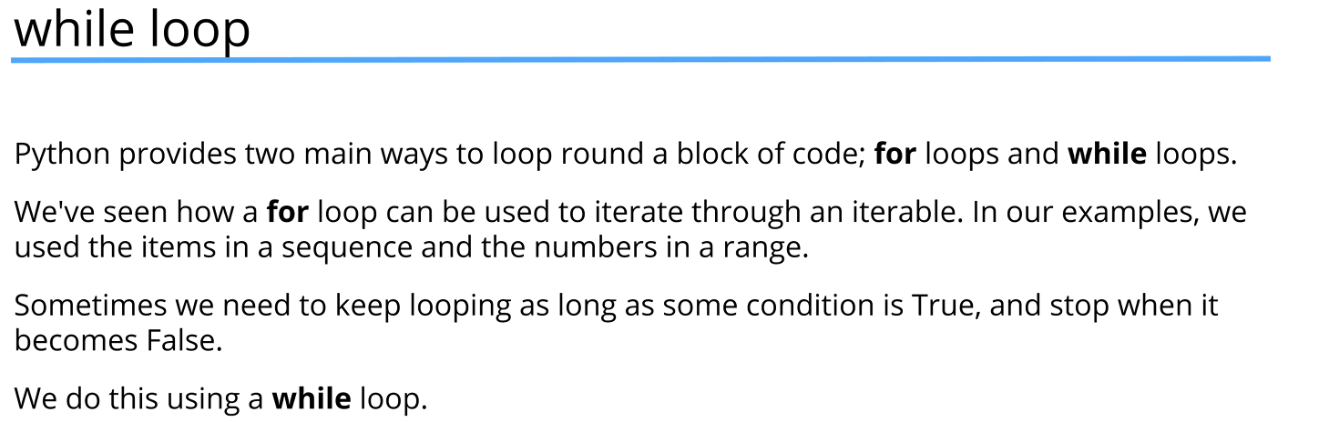
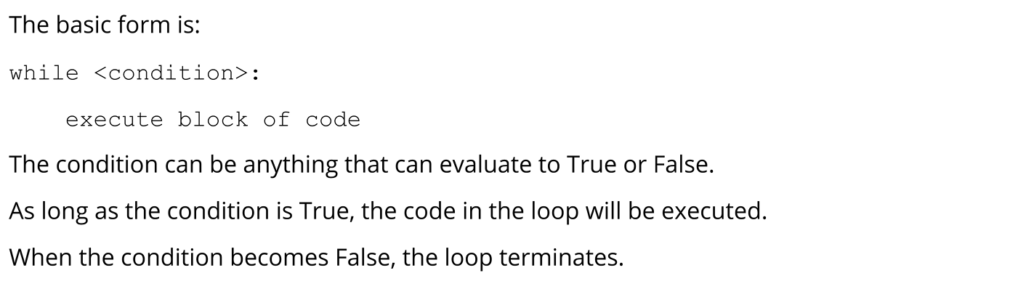
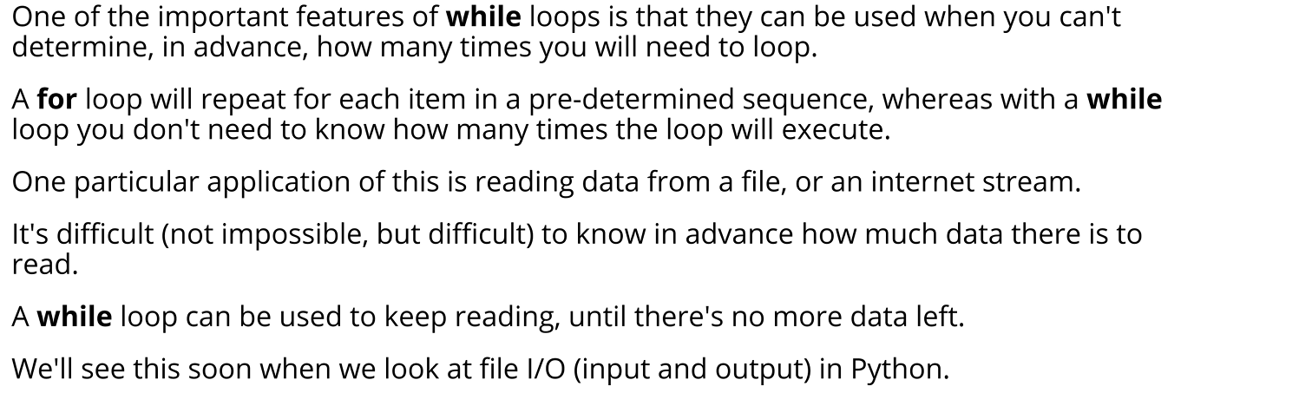
print("Foor loop")
for i in range(10):
print("i is now {}".format(i))

print("-" * 10)

print("While loop")
i = 0

while i < 10:
print("i is now {}".format(i))
i += 1

available_exits = ["north", "south", "east", "west"]

chosen_exit = input("Please choose valid direction: ")

while chosen_exit not in available_exits:
chosen_exit = input("Please choose valid direction: ")

if chosen_exit == "quit":
print("Game over!")
#break does the same thing with while loop as for loop
#it stops the loop
break

print("aren't you glad you got out of there")

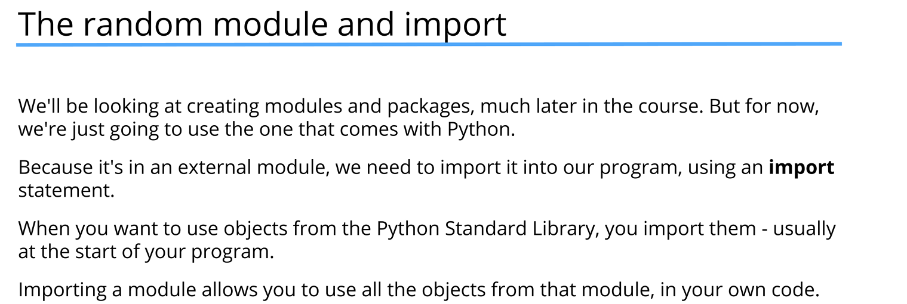
import random

#we can use functions inside random module using dot notation
#dot notation tells Python that it can find randint function
#inside the random module
#randint function returns random number in range including end point

LOWEST = 1
HIGHEST = 10

#generate random number
answer = random.randint(1, 10)
print(answer) #TODO:Remove after testing!

user_guess = None

#repeat until user guess is correct
while user_guess != answer:
user_guess = int(input("Please guess a number between {} and {} or 0 to quit: ".format(LOWEST, HIGHEST)))

#exit if 0 is typed
if user_guess == 0:
print("You exited the game!")
break

#display win message if user guess is correct
if user_guess == answer:
print("Congratulations. You got it right!")
break

if user_guess > answer:
print("Please guess lower!")
else:
print("Please guess higher!")

